case Scripts:

- #!/bin/bash
- echo
- echo Please chose one of the options below
- echo
- echo 'a = Display Date and Time'
- echo 'b = List file and directories'
- echo 'c = List users logged in'
- echo 'd = Check System uptime'
- echo
read choices
case $choices in
a) date;;
b) ls;;
c) who;;
d) uptime;;
*) echo Invalid choice - Bye.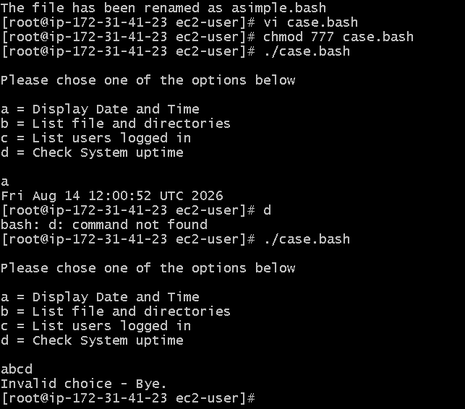

This script will look at your current day and tell you the state of the
backup
- #!/bin/bash
- NOW=$(date +"%a")
- case $NOW in
- Mon)
- echo "Full backup";;
- Tue|Wed|Thu|Fri)
- echo "Partial backup";;
- Sat|Sun)
- echo "No backup";;
- *) ;;
Esac
